Rassina Primary school, 4th years section A. Teacher Franco Giuliano.
Project “FOOD CHAINS”: the first and the second lesson

LESSONS PLANNING PROCESS
1 LESSON
Warmer and co-contructing:
- Discussing about animals. The teacher explains that this year we will learn something about animals, their habitat and the movement of energy through a food chain
- Also we learn identify and define the key organisms in a food chain and create a model of a food chain.

Scaffolding/Communication
- First the teacher presents some animal images on the whiteboard.
- The teacher starts from the images they should already know
- The children NAME all the animals they already know.
- The teacher writes on blackboard three words (keywords): producer, consumer, decomposer
- The teacher shows a slideshow to the children with a definition of a food chain and introduces the three key terms students will be expected to know.

Developing skills strategies:
- The teacher reads the definition of food chain with the support of the cards showing the transfer of energy.
- Teacher shows some animal, plants and other organism images on witheboard and student answer, by a Thumbs Up or Down activity, if the definition (producer, consumer, decomposer) written under the image is correct

Cooperation:
- The class is divided into four groups; the teacher deliveries a set of cards to each group: students must put the cards in the correct order according to the food chain definition.

2 LESSON
Warmer and co-contructing:
- Sing Adventure Time - Food Chain Song (https://www.youtube.com/watch?v=VQFhd3X8p6g)

Scaffolding:
- Review of Food Chains slideshow
- The teachers shows a documentary on the animals and their habitat (https://www.youtube.com/watch?v=xx0_MvlseBc)

Reflections and learning process:
- The teacher gives a questionnaire to the pupils to check their understanding about the lessons
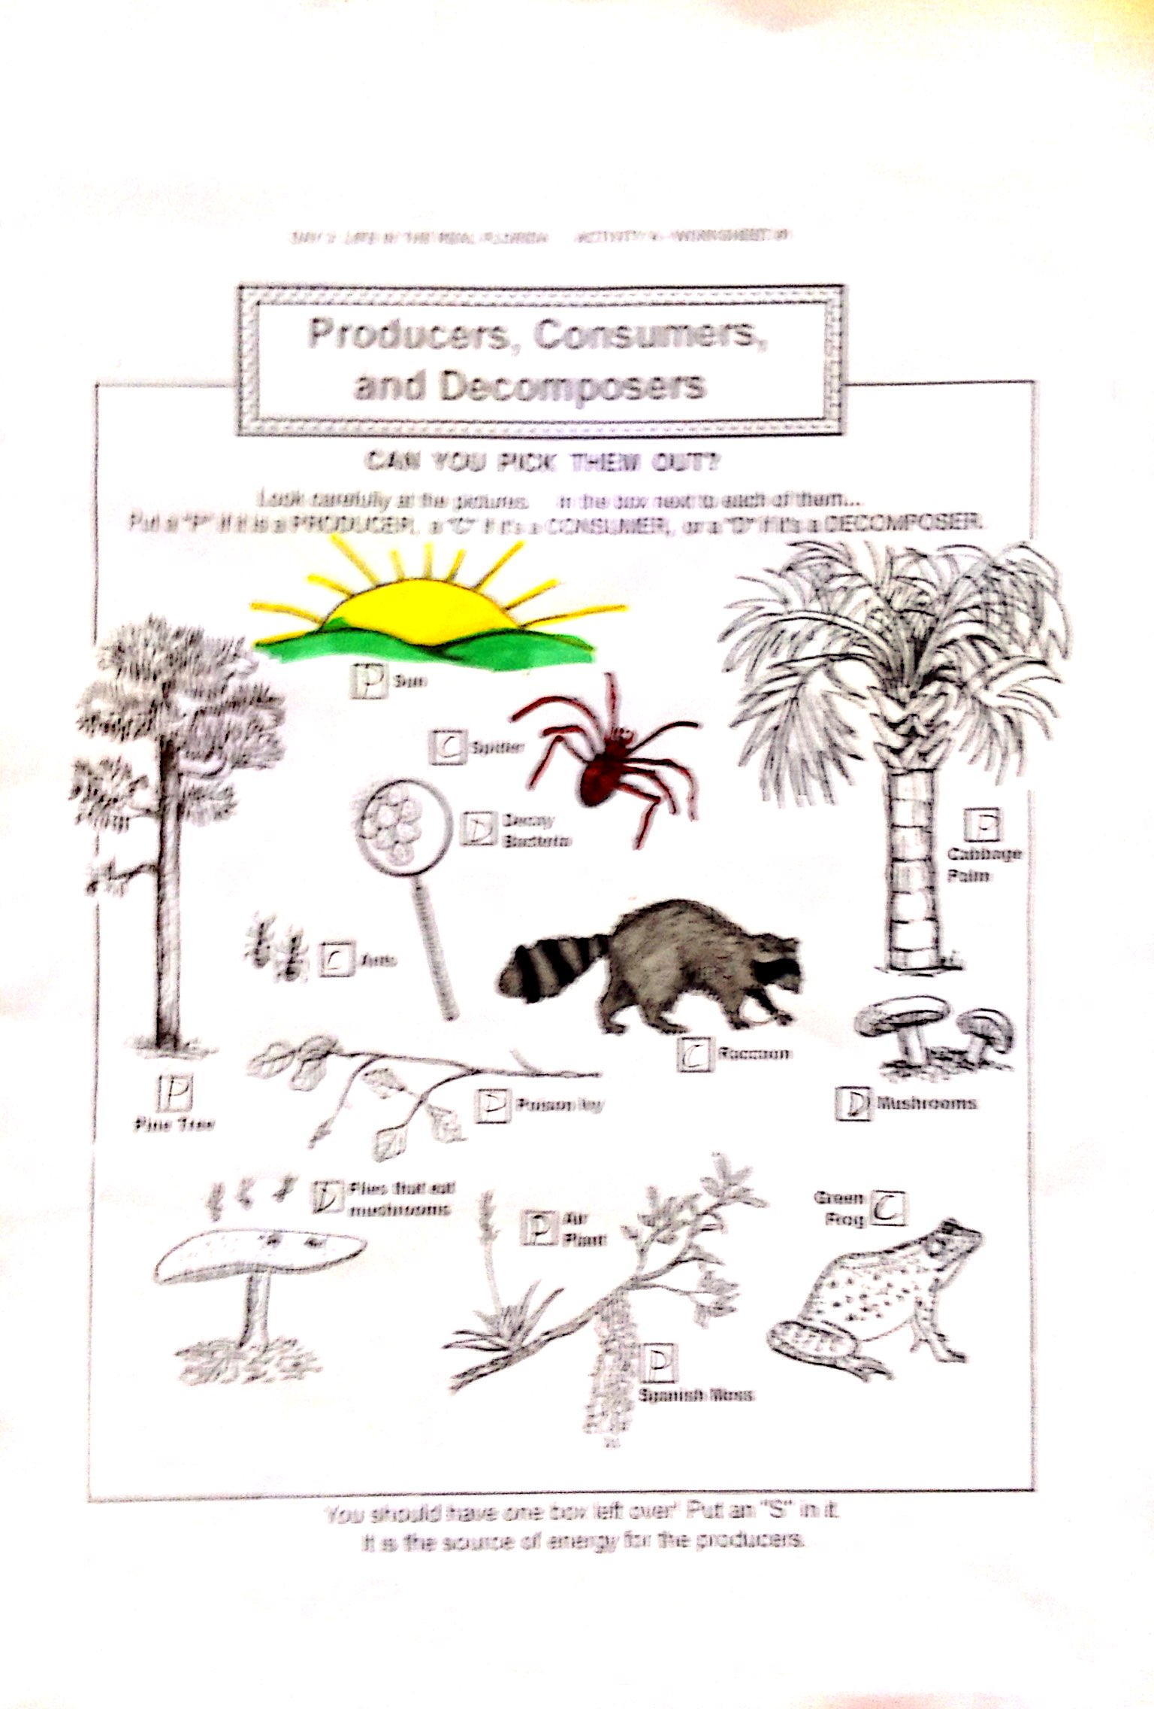

Cooperation:
- The class is divided into six groups and each team must prepare a boarding of a food chain

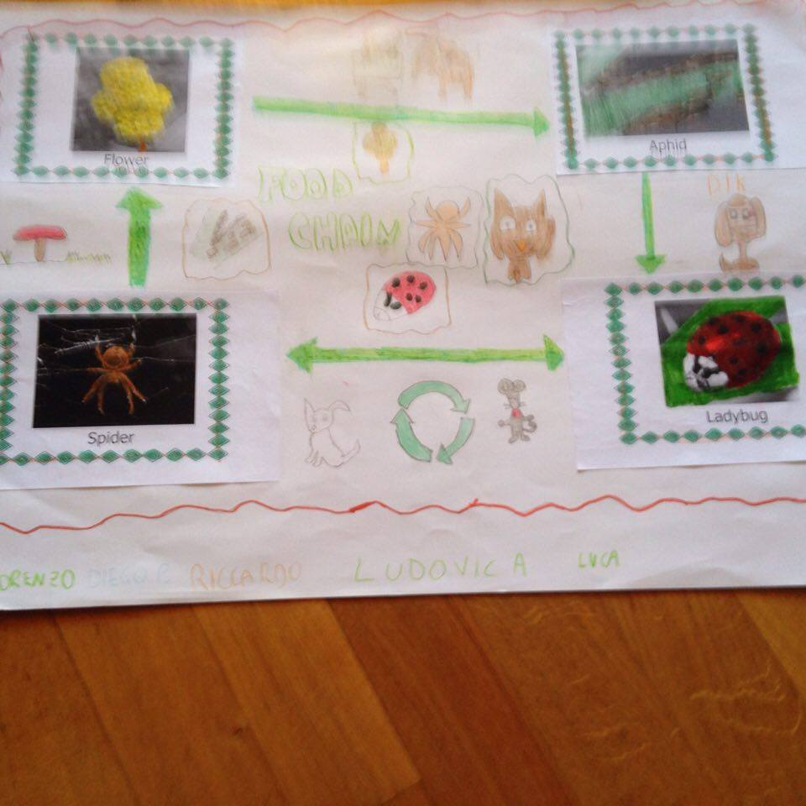

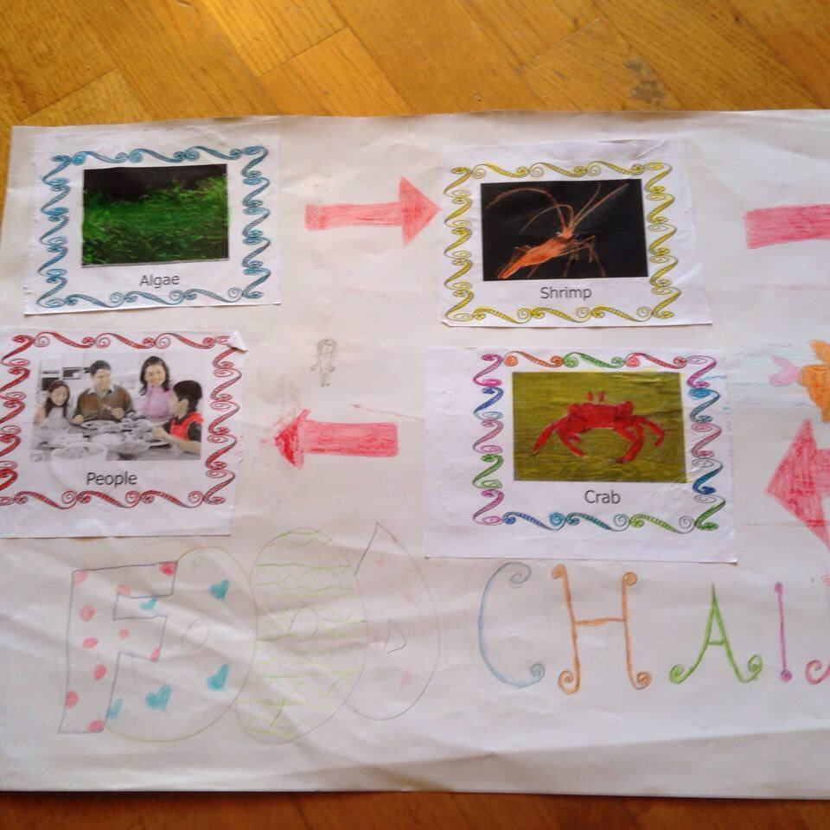

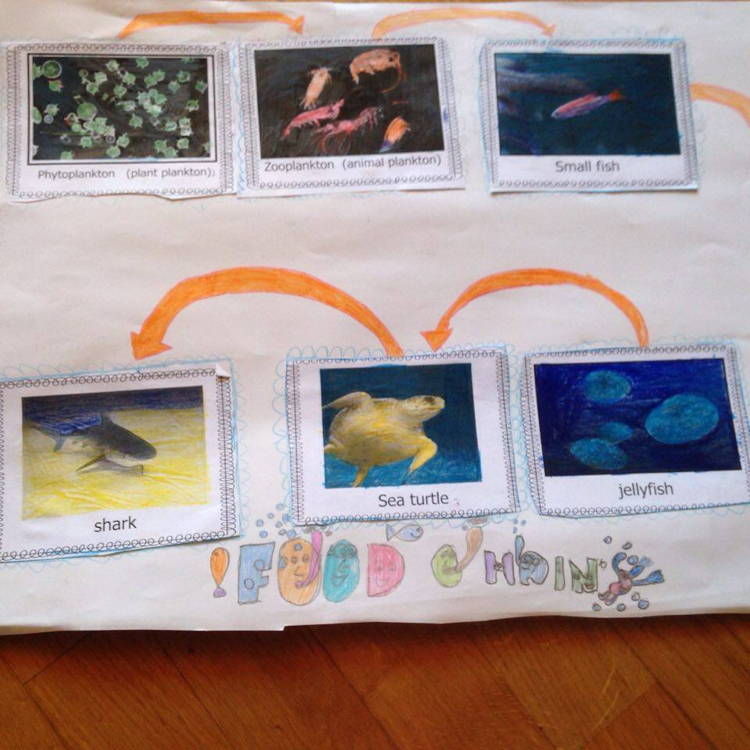

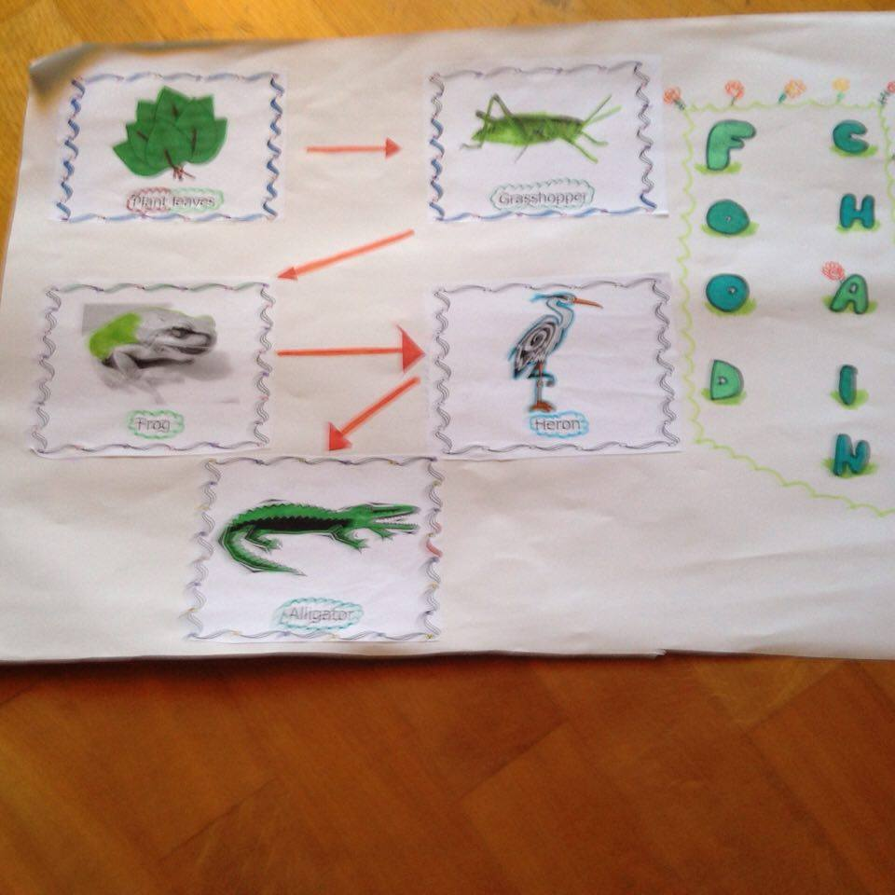

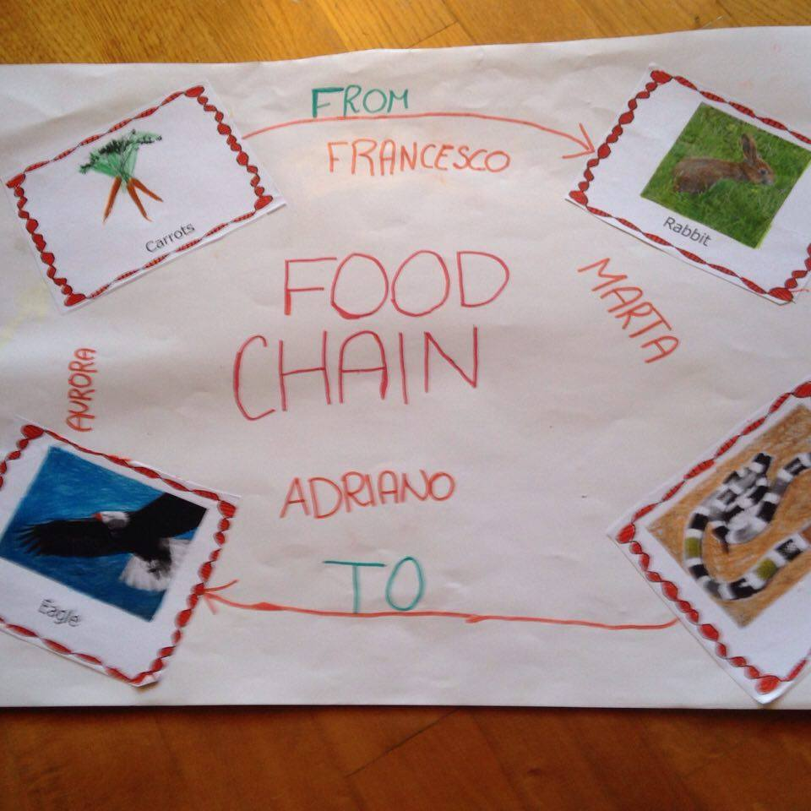
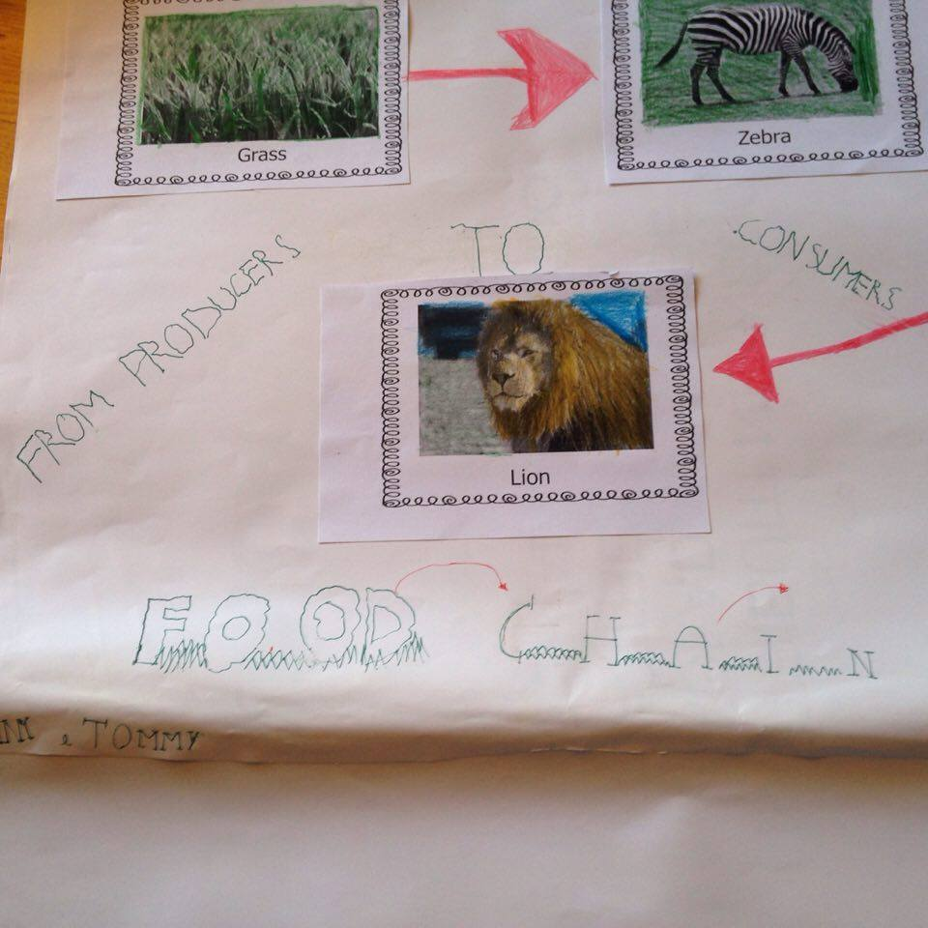

Communication:
- Each group presents to the rest the class their boarding.

Assessment:
- Self-assessment- everyone put a smile on the grid prepared by teacher on blackboard
- The questionnaire results

Strengths
- Attractive subject, interaction between pupils/teacher, cooperative learning, whiteboard

Weaknesses
- high number of students , too confined spaces

FOOD CHAINS –A PROJECT FOR THE COURSE IVA OF THE PRIMARY SCHOOL OF RASSINA
CONTENT | COGNITION | CULTURE | COMMUNICATION
FOOD CHAINS  - I will explain: the movement of energy through a food chain; identify and define the key organisms in a food chain; create a model of a food chain.  - Language aims:  - Time words (order, first, then, at the end)  - Key words;: energy, producers, consumers, decomposers, environment | - Recognize animals, organisms and habitat  - Order animals and organisms according to a scheme  - Prepare some classroom poster | - Make pupils active citizen into the environmental protection  - Understanding that the individuals are included in life cycle. | - Discuss in group/pairs  - Present food chain posters through images and drawing  - Earn some new words of science vocabulary  - use a language accessible to the class, considering special needs  - improve their language skills

